**Departments - PHYSICS - Extension Activities**

                                      NATIONAL SCIENCE DAY CELEBRATIONS

National Science Day, observed annually on February 28, commemorates the discovery of the Raman Effect by Indian physicist Sir CV Raman. This year's theme, "Indigenous Technologies for Viksit Bharat," highlights the importance of homegrown innovations and scientific progress in India. The day aims to promote scientific temper, inspire youth towards careers in science, and celebrate India's rich scientific heritage.

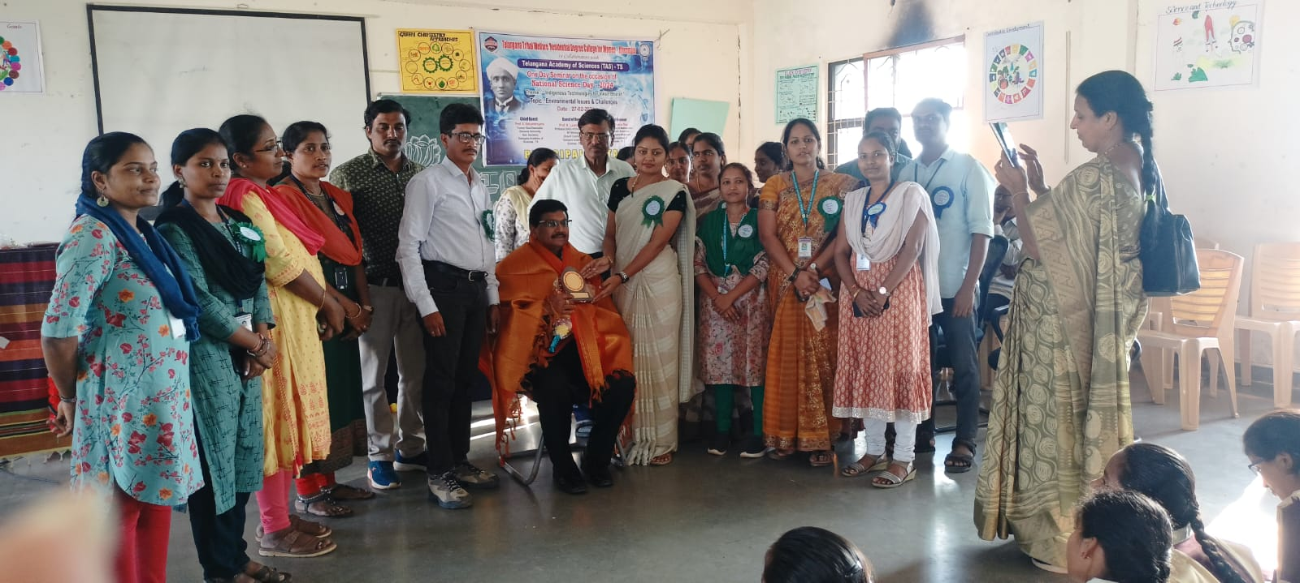  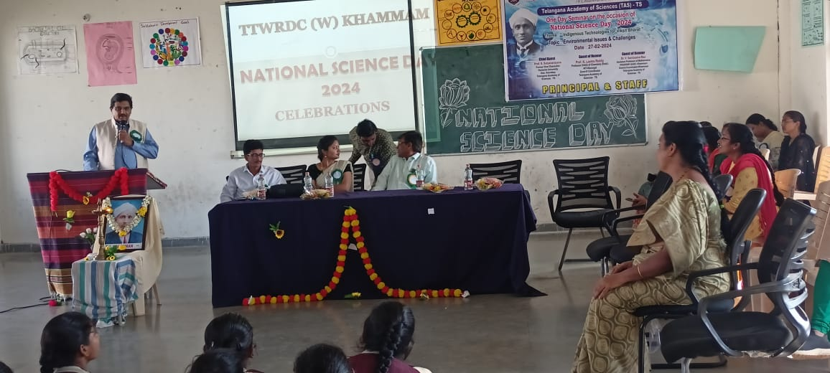

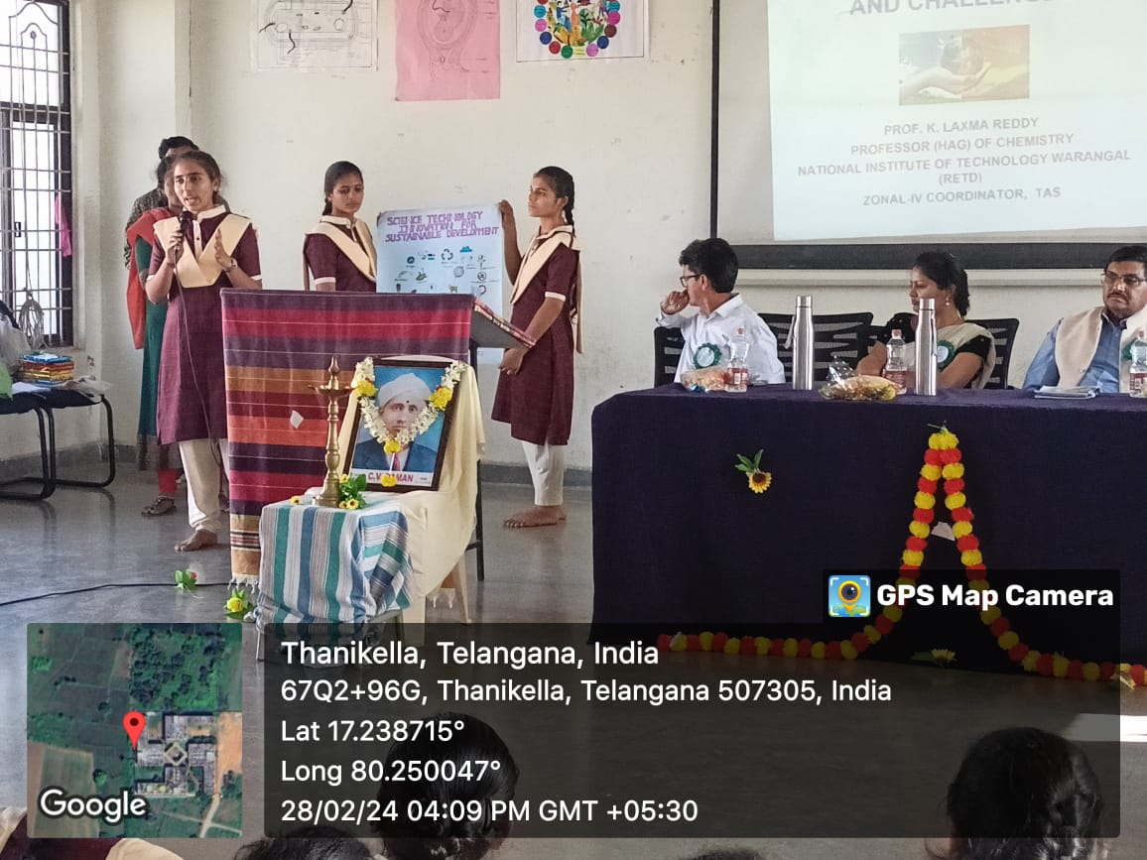 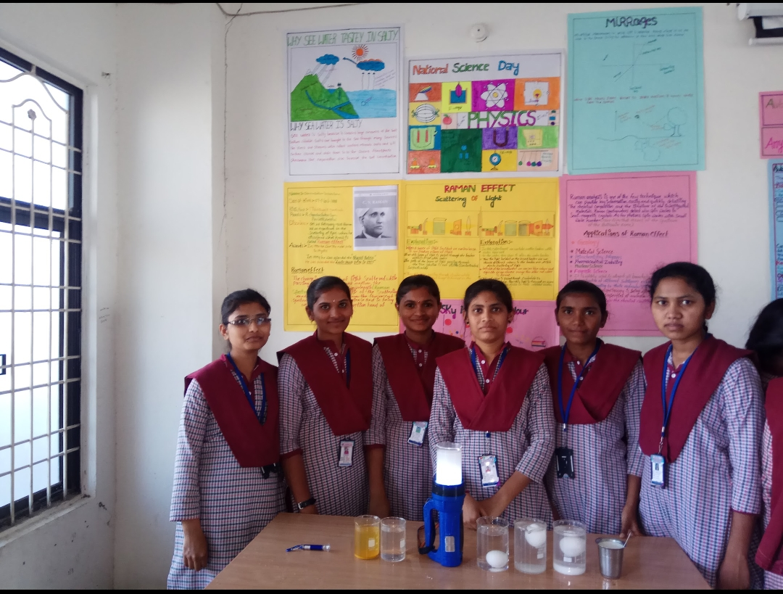

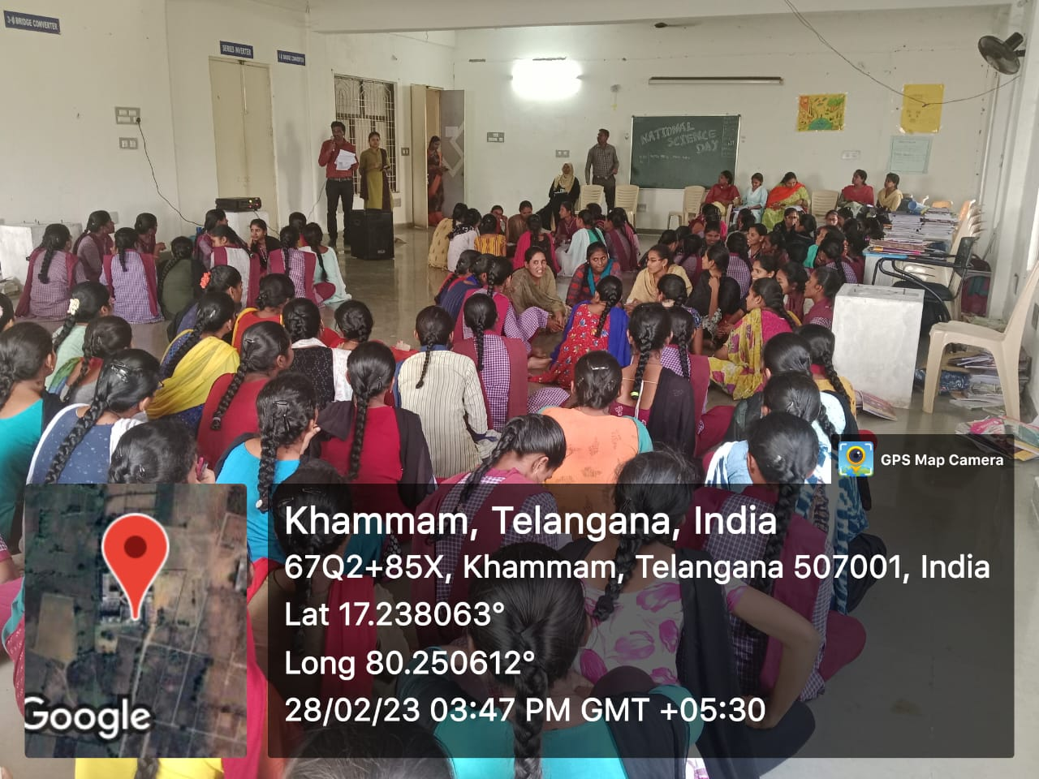 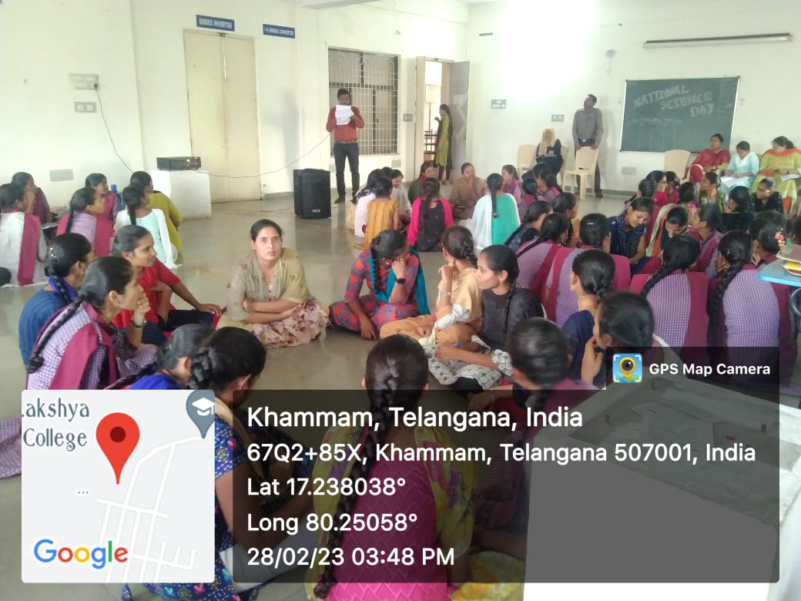

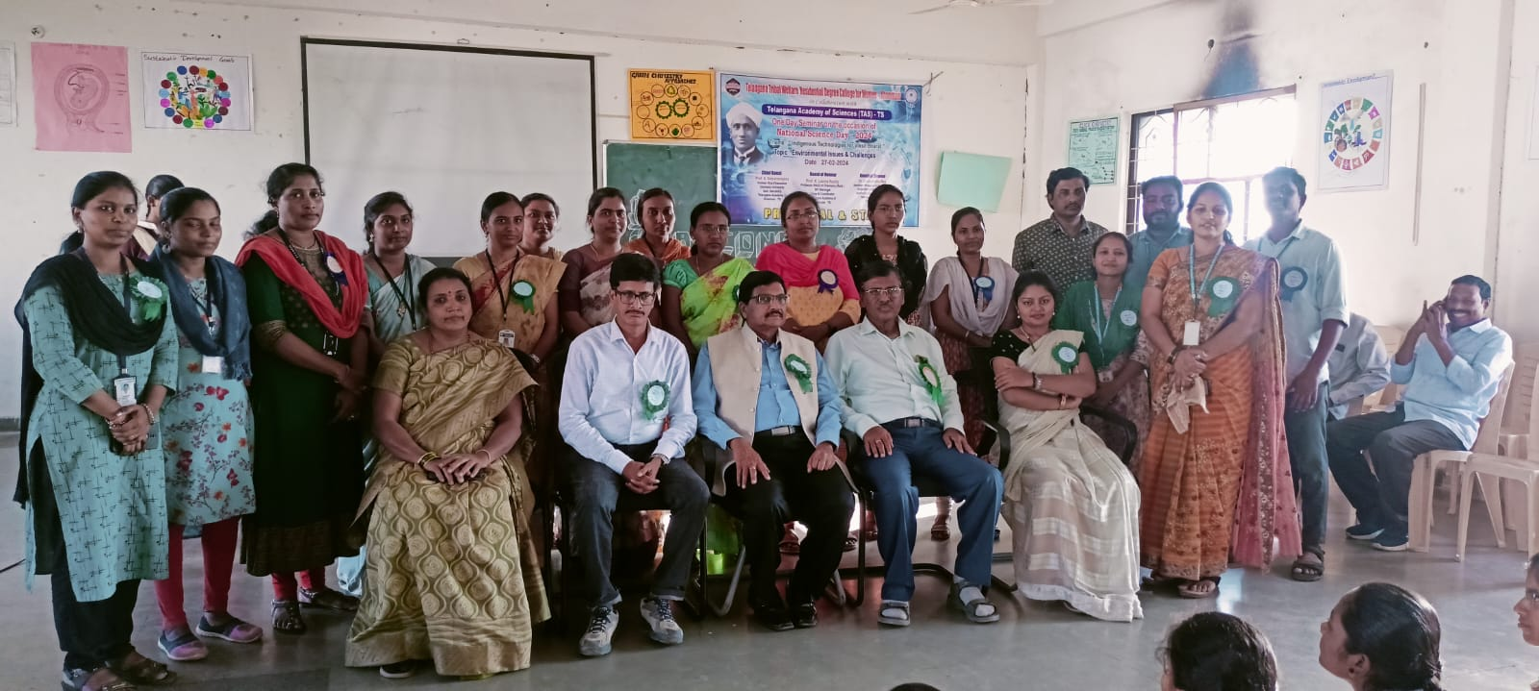

REPORT ON NATIONAL SPACE DAY

Recently, India celebrated its**first National Space Day** on 23rd August 2024. It is celebrated to mark the **safe and soft landing of Vikram Lander** of [**Chandrayaan-3 mission**](https://www.drishtiias.com/daily-updates/daily-news-editorials/chandrayaan-3-india-s-imperatives-for-space-leadership), on the lunar surface on **23rd August 2023**.

* Additionally, the recent findings based on **Chandrayaan-3,** represent the first analysis of the Moon’s southern topsoil composition and support the hypothesis of the sea of molten material on the lunar surface.
* 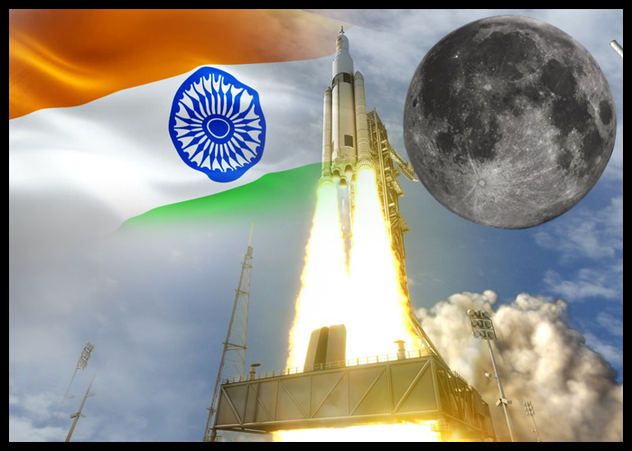

**CELEBRATION OF NATIONAL SPACE DAY**:

* + **National Space Day, celebrated on 23rd August,**commemorates India's space achievements, particularly Chandrayaan-3's success.
  + With the launch of **Chandrayaan-3** in 2023, India became the **fourth nation to successfully land** on the Moon and the **first to reach its southern polar region.**
  + It highlights India's space exploration capabilities and aims to inspire future generations to pursue careers in [**science, technology, engineering, and mathematics (STEM)**](https://www.drishtiias.com/daily-news-analysis/women-participation-in-stem), contributing to India's ongoing space endeavours.
* **Theme for 2024:**

**The theme for National Space Day 2024 is ‘Touching Lives while Touching the Moon: India's Space Saga’**.

**Recent Findings of Chandrayaan-3:**

* **Key Findings:**
  + The terrain around **Chandrayaan 3’s** landing sight is fairly uniform.
  + A **sea of hot, molten rock or magma** once existed under the lunar surface.
  + The **Moon’s crust was formed layer by layer,** which supports the **lunar magma ocean (LMO) hypothesis**.
  + The **topsoil around the lunar south pole** has a greater-than-expected sprinkling of minerals which compose the lower layers of the lunar crust.
* **LMO Hypothesis and Lunar Crust Formation:**
  + The **Moon is believed to have formed from a giant**[**asteroid**](https://www.drishtiias.com/daily-updates/daily-news-analysis/near-earth-asteroid-ryugu)**impact** with Earth about 4.5 billion years ago, creating a **molten surface** that eventually cooled.
  + In this process, **heavier minerals** like **olivine and pyroxene** sank to the lower crust and upper mantle, while **lighter minerals like calcium**and sodium-based compounds**floated to form the upper crust.**

**Highlights of Indian Space Missions in 2003-24:**

* **Aditya-L1 Mission:**
  + [**Aditya-L1**](https://www.drishtiias.com/daily-updates/daily-news-analysis/aditya-l1-mission-2) is the first **space based observatory class Indian solar mission** to study the Sun from the first **Earth-Sun Lagrange point, L1**.
* **Gaganyaan TV-D1 Test:**
  + ISRO conducted its [**Flight Test Vehicle Abort Mission-1 (TV-D1)**](https://www.drishtiias.com/daily-updates/daily-news-analysis/test-on-crew-escape-system), using a modified [**L-40 Vikas engine**](https://www.drishtiias.com/daily-news-analysis/upgraded-vikas-engine=to-boost-isros-rockets) for the **Gaganyaan** human spaceflight mission.
  + The test demonstrated the **Crew Escape System (CES)** capabilities, including **separation from the test vehicle, crew module safety, and deceleration** before splashdown in the Bay of Bengal. The module was recovered by the Indian Navy vessel [**INS Shakthi**](https://www.drishtiias.com/daily-updates/daily-news-analysis/visit-of-indian-naval-ships-to-malaysia).
* **XPoSat Launch:**
  + On 1st January 2024, ISRO launched the [**X-ray Polarimeter Satellite (XPoSat)**](https://www.drishtiias.com/daily-updates/daily-news-analysis/xposat), aimed at studying **radiation polarisation in space**.
  + The satellite is the second space-based observatory of its kind, following [**NASA’s Imaging X-ray Polarimetry Explorer (IPEX)**](https://www.drishtiias.com/daily-news-analysis/nasa-s-ixpe-mission) launched in 2021.
* **RLV-TD Experiments:**
  + ISRO conducted two landing experiments using a downscaled version of the [**Reusable Launch Vehicle, Pushpak**](https://www.drishtiias.com/daily-updates/daily-news-analysis/pushpak-isro-s-reusable-launch-vehicle), in March and June 2024, at its **Aeronautical Testing Range**Challakere, Karnataka.
  + These tests simulated space landing conditions, with Pushpak being dropped from a [**Chinook helicopter**](https://www.drishtiias.com/daily-updates/daily-news-analysis/important-facts-for-prelims-26th-march-2019) to assess landing performance.
* **SSLV Development:**
  + In August 2024, ISRO launched the third and final development flight of the [**Small Satellite Launch Vehicle (SSLV)**](https://www.drishtiias.com/daily-updates/daily-news-analysis/completion-of-sslv-development-project), successfully placing the **EOS-08 and SR-0 Demosat satellites** in orbit.
  + With two consecutive successful test flights, ISRO concluded the SSLV’s development and transferred it to industry.
* **Private Space Missions:**
  + In March 2024, **[Agnikul Cosmos](https://www.drishtiias.com/daily-updates/daily-news-analysis/india-s-first-3d-printed-rocket-engine-launched" \t "_blank)** successfully launched its **SoRTeD-01 vehicle**, marking the first launch of a vehicle powered by a [**semi-cryogenic engine**](https://www.drishtiias.com/daily-news-analysis/semi-cryogenic-propellant-tank#:~:text=Unlike%20a%20Cryogenic%20engine%2C%20a,stored%20in%20a%20normal%20temperature.) as its first stage from Indian soil.
  + **Skyroot Aerospace** is progressing towards its **[Vikram 1 launch vehicle](https://www.drishtiias.com/daily-updates/daily-news-analysis/successful-test-firing-of-vikram-1-stage-2" \l ":~:text=Vikram%2D1%20marks%20India's%20first,in%20space%20technology%20and%20exploration." \t "_blank)**.
  + **Dhruva Space and Bellatrix Aerospace** conducted experiments on the fourth stage of the [**PSLV-C58**](https://www.drishtiias.com/daily-updates/daily-news-analysis/green-propulsion-system#:~:text=What%20is%20the%20PSLV%2DC58,ray%20emission%20from%20celestial%20sources.) mission in January 2024, utilising the stage as an orbiting platform for their payloads.

**NATIONAL SPACE DAY CELEBRATIONS IN TGTWRDC FOR GIRLS, KHAMMAM**

National space day has been celebrated in TGTWRDC FOR GIRLS in khammam on 23rd August 2024. To commemorate the celebrations, quiz and picture presentation competitions have been conducted on 22nd August itself.

Students have actively participated in the competitions and won the prizes irrespective of their group and branch they are studying. Taking it as a pride of INDIA everyone enthusiastically answered the questions and were very excited during the program.

Department of physics and chemistry have combinedly organized this program which was a grand success in celebrating special days in our college.

Competitions on 22nd August 2024:

* + 1. Quiz: Quiz has been conducted to the students of the whole college in the achievements of India in space exploration.

The following students are the winners and runners in the quiz and poster presentation competition:

Quiz:

|  |  |  |  |
| --- | --- | --- | --- |
| Winners name | Group&year | Runners name | Group &year |
| J.KAVYA | III MBZC | M.KAVYA | IIMPCS |
| T.RAMYA | IMPCS | K.SRAVANI | IIMPCS |
| D.POOJITHA | IIIMPCS | G.ANITHA | IIMPCS |
| P.SHARANYA | I MPCS | CH.KAVYA | IMPCS |
| G.MALLISWARI | IMPCS | A.VIDYASRI | IMPCS |
| CH.DIVYA | IIIBZC | T.SUDHARANI | IIMSDS |
| L.MOUNIKA | IIIMPCS | B.INDHU | IIIMPCS |

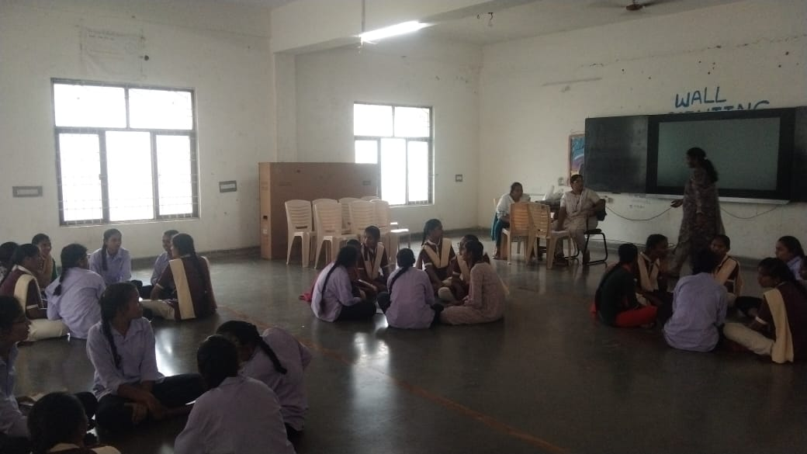

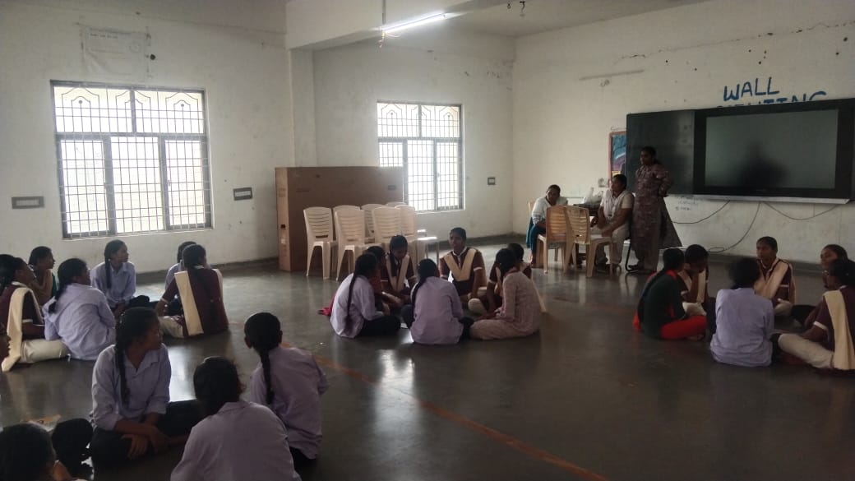

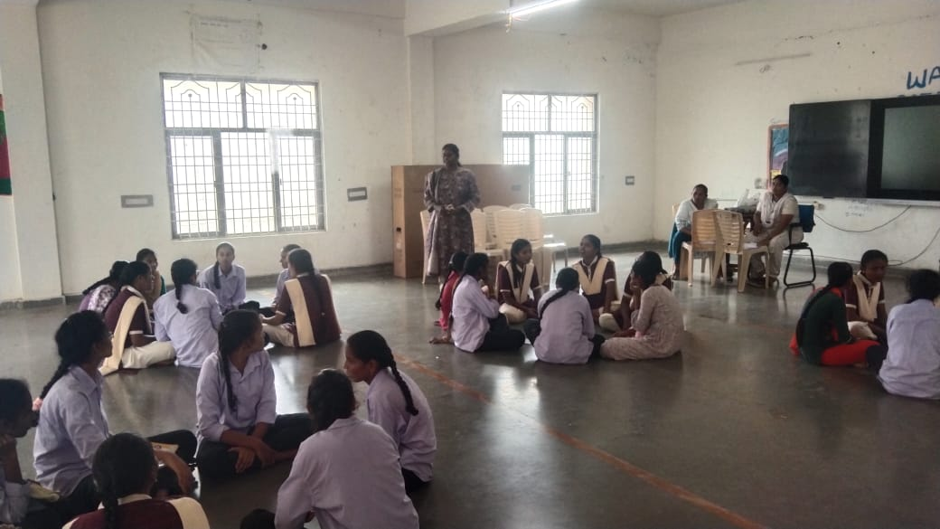

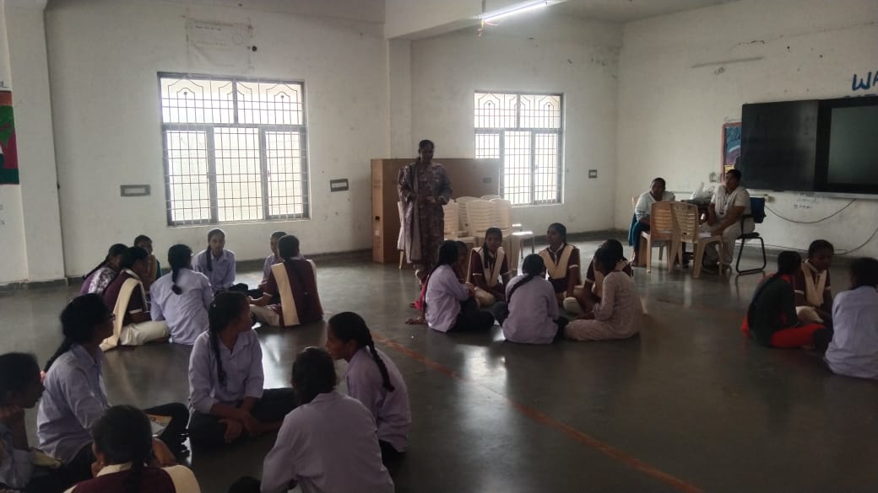

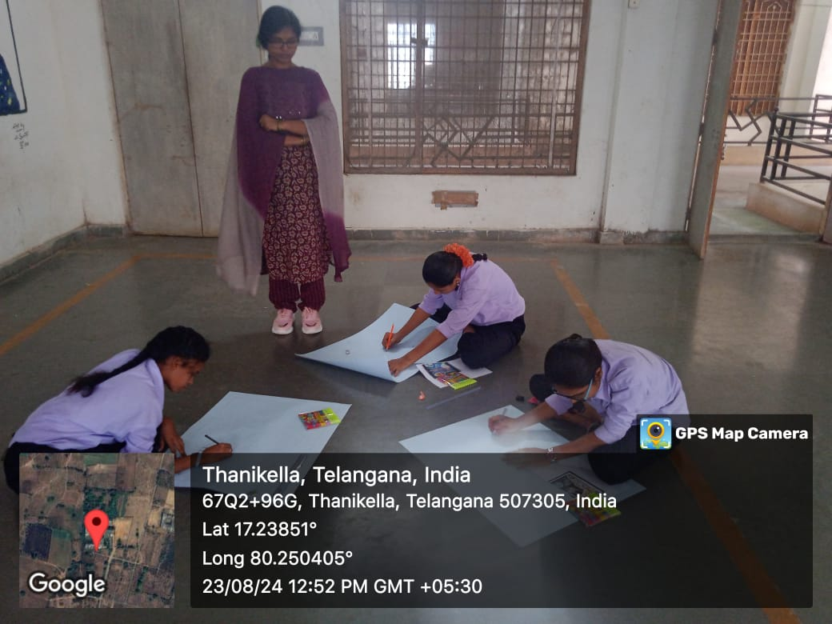

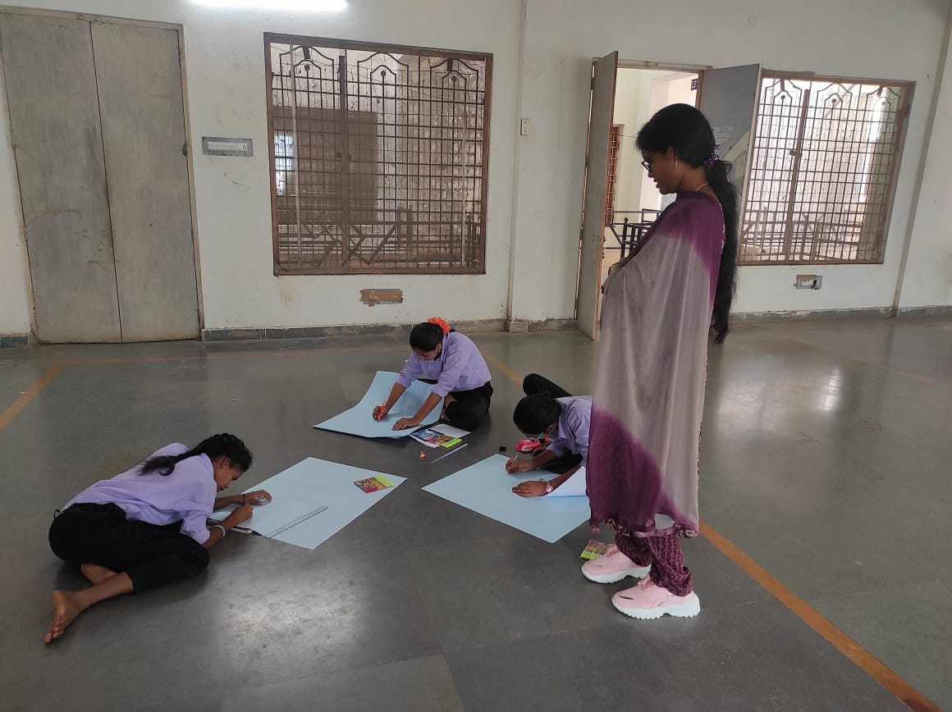

INAUGURATION OF SPACE DAY CELEBRATIONS:

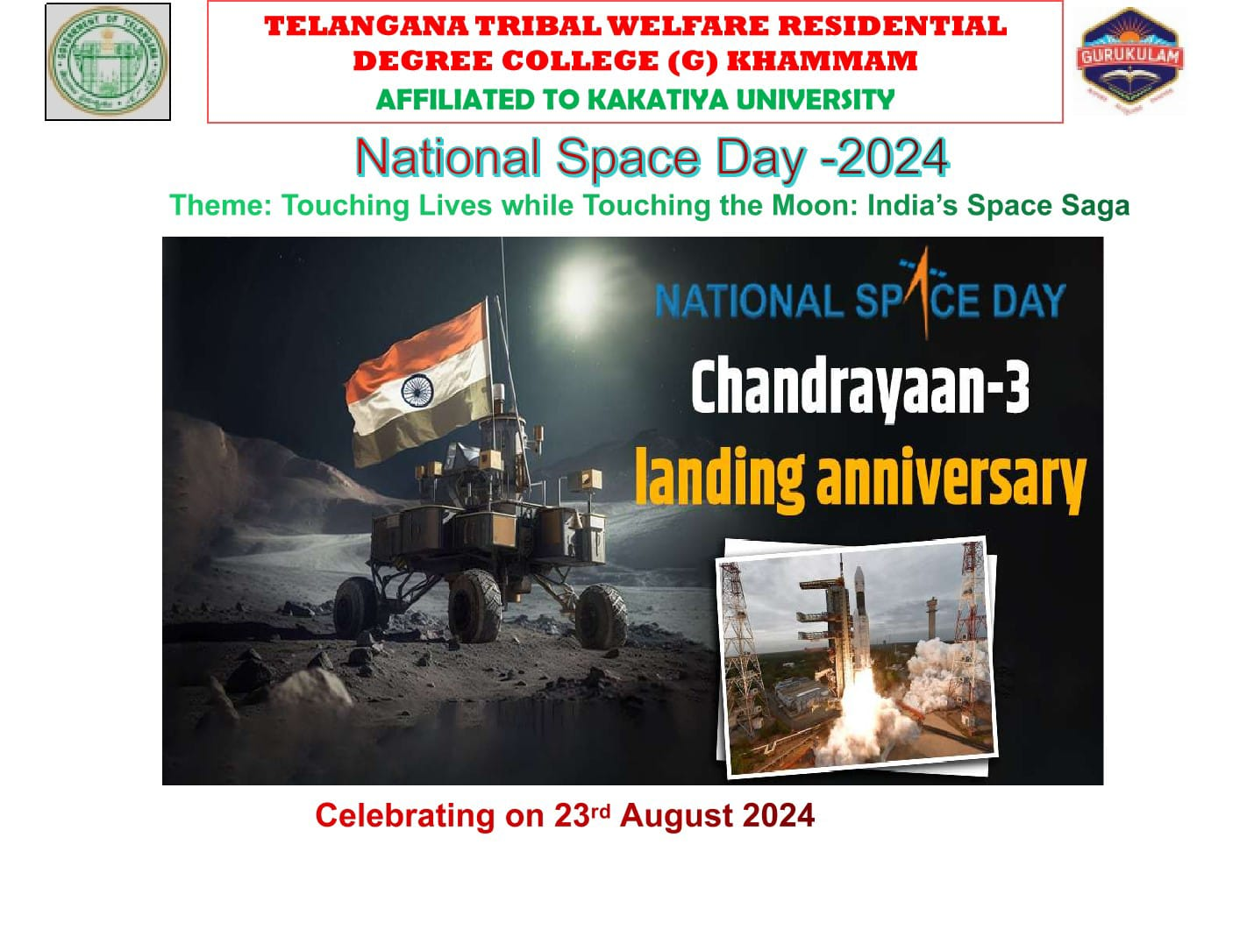

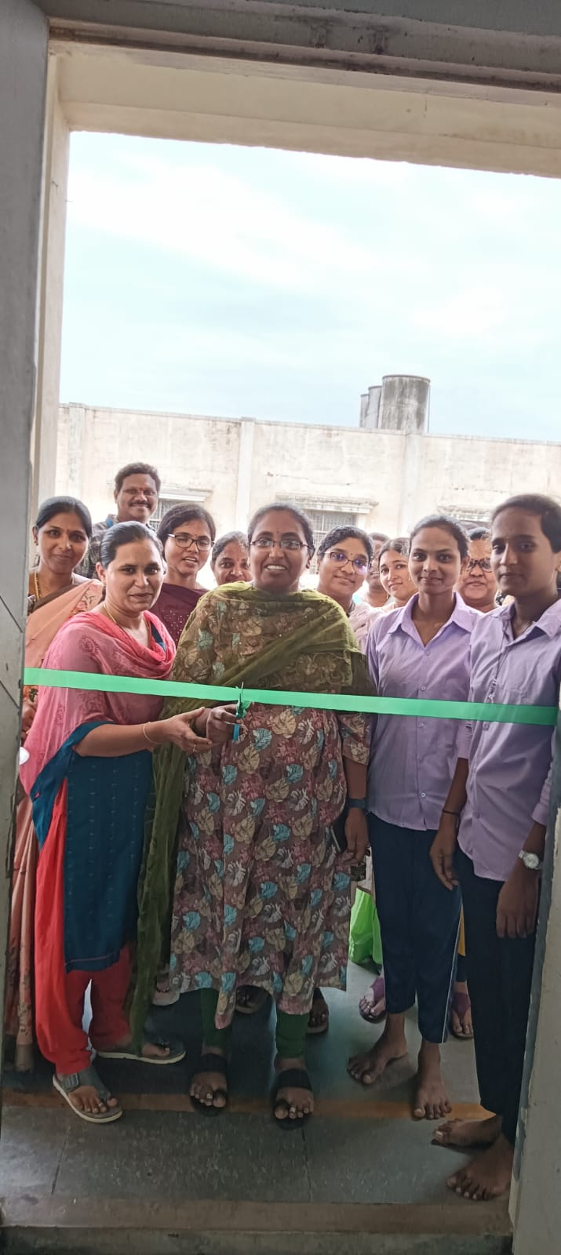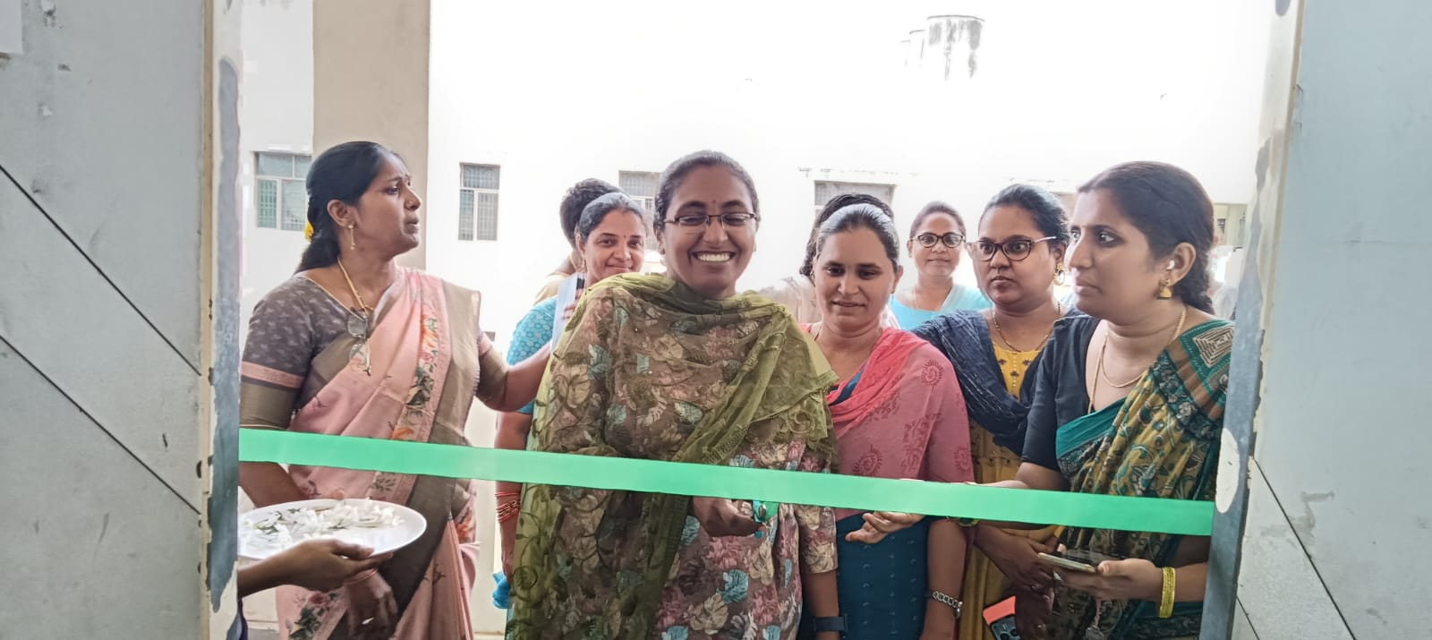

**2.POSTER PRESENTATION:**

**PARTICIPANTS:**

**CH.DEEPIKA IIIB.COM (G)**

**G.SRUTHI II MBZC**

**A.SRAVANI IIMPC (W)**

**B.INDHU IIIMPCS(R)**

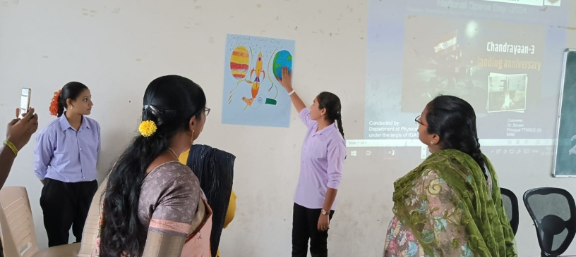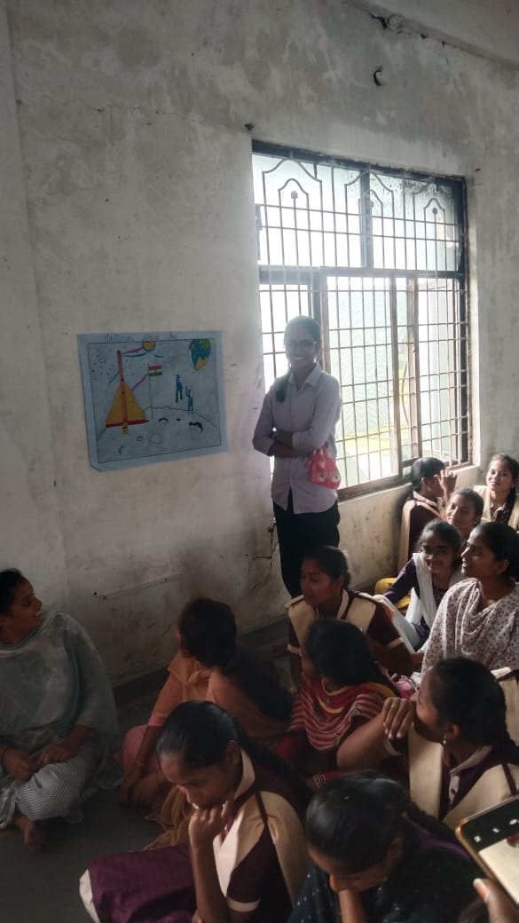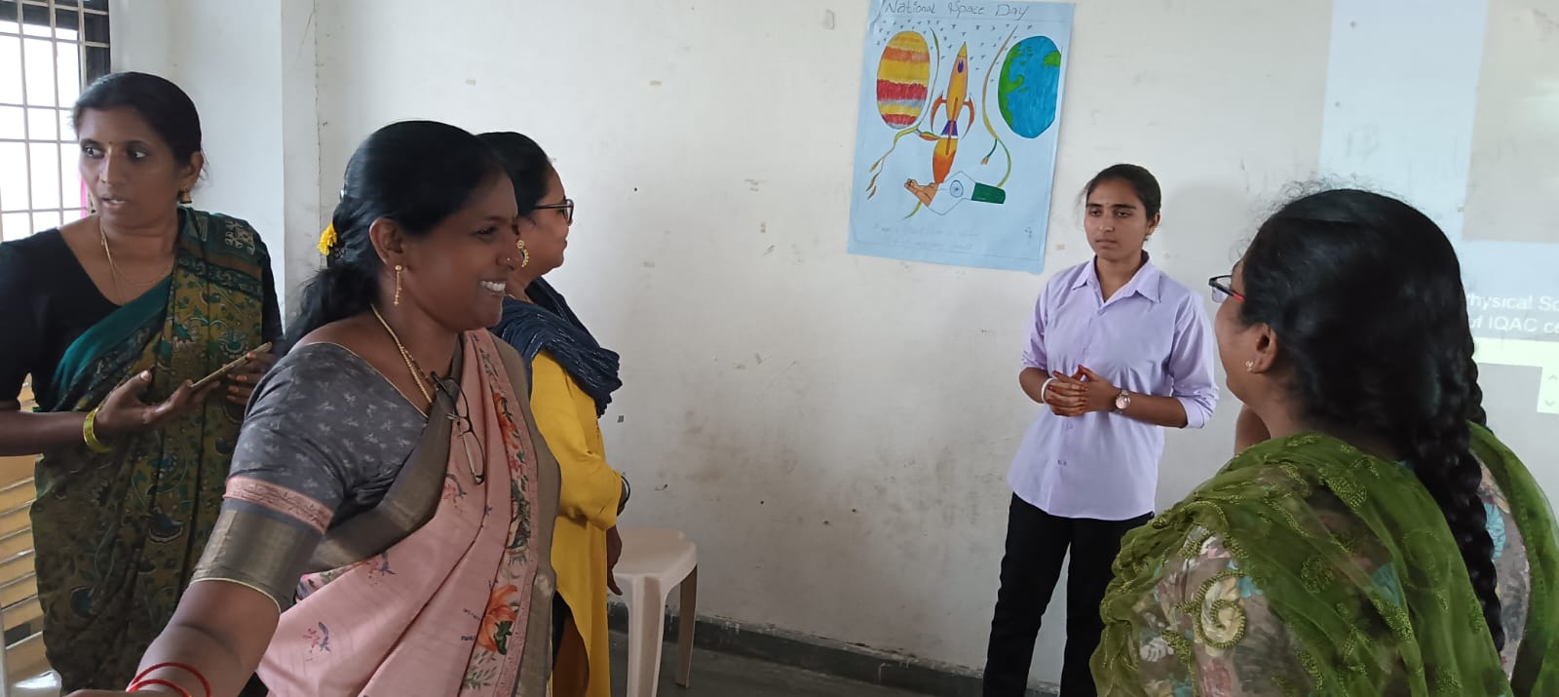

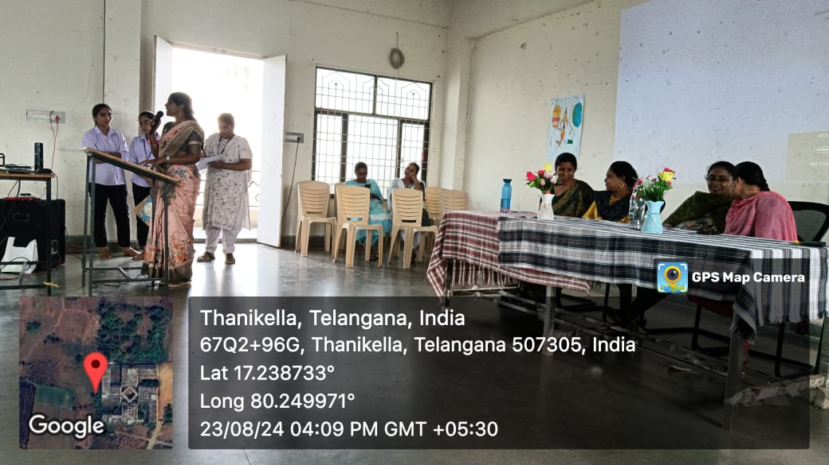

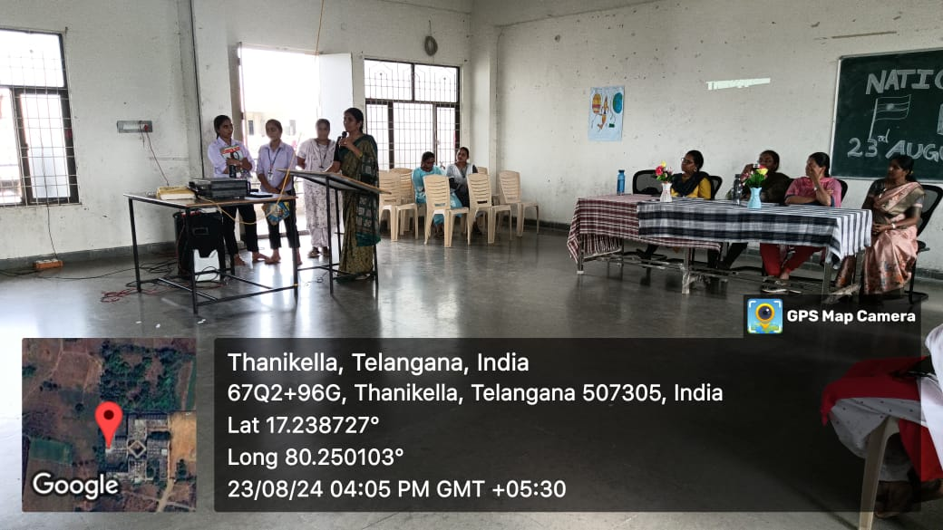

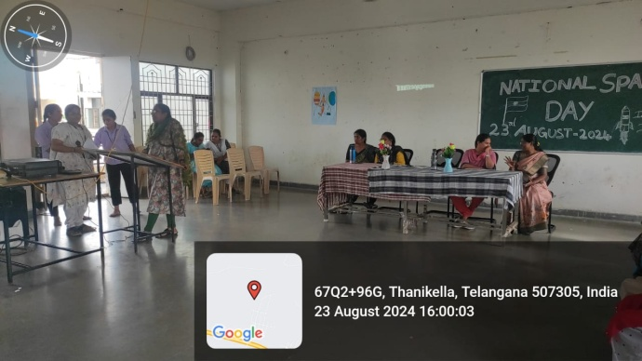

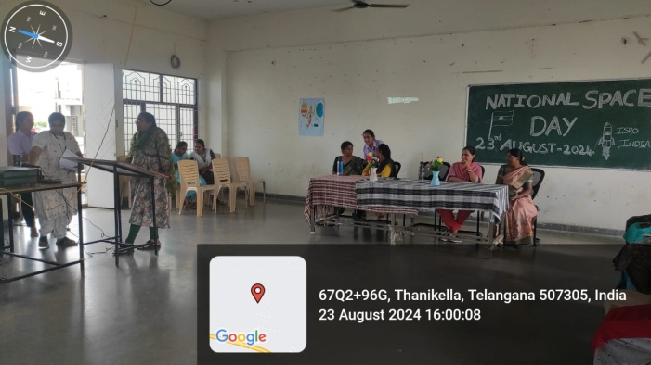

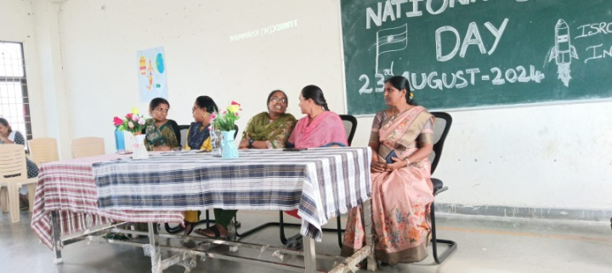

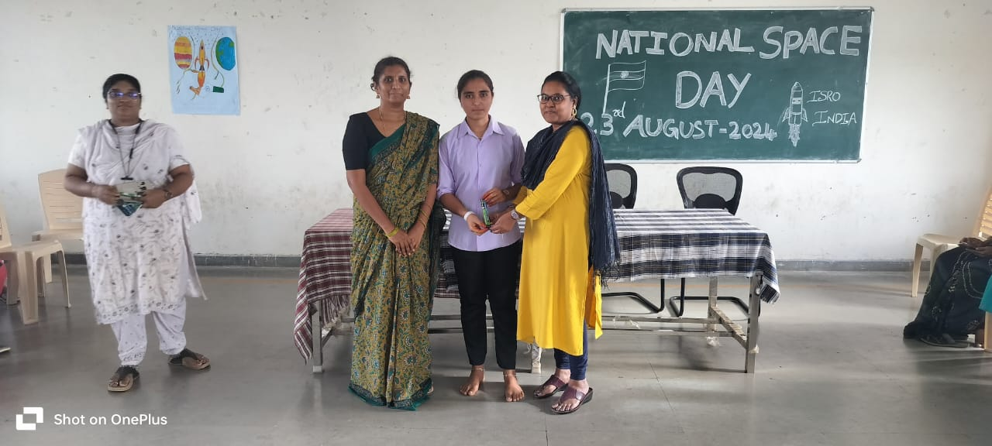

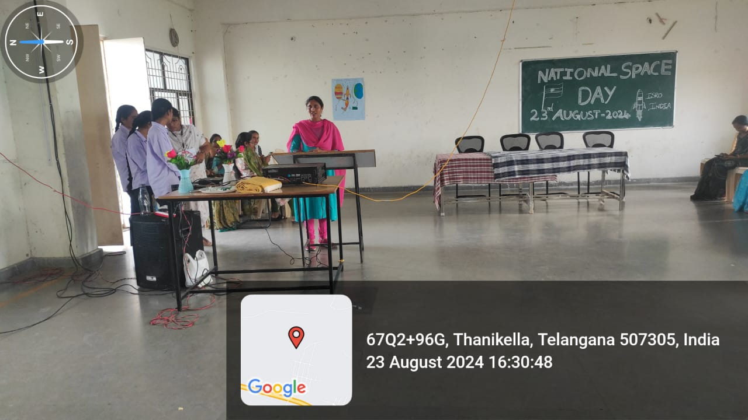

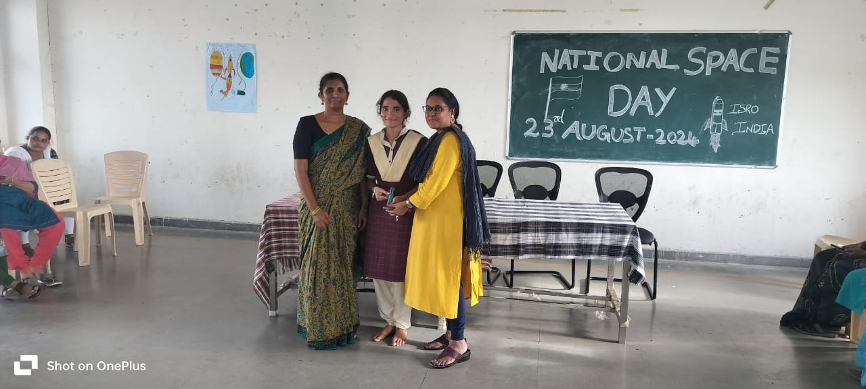

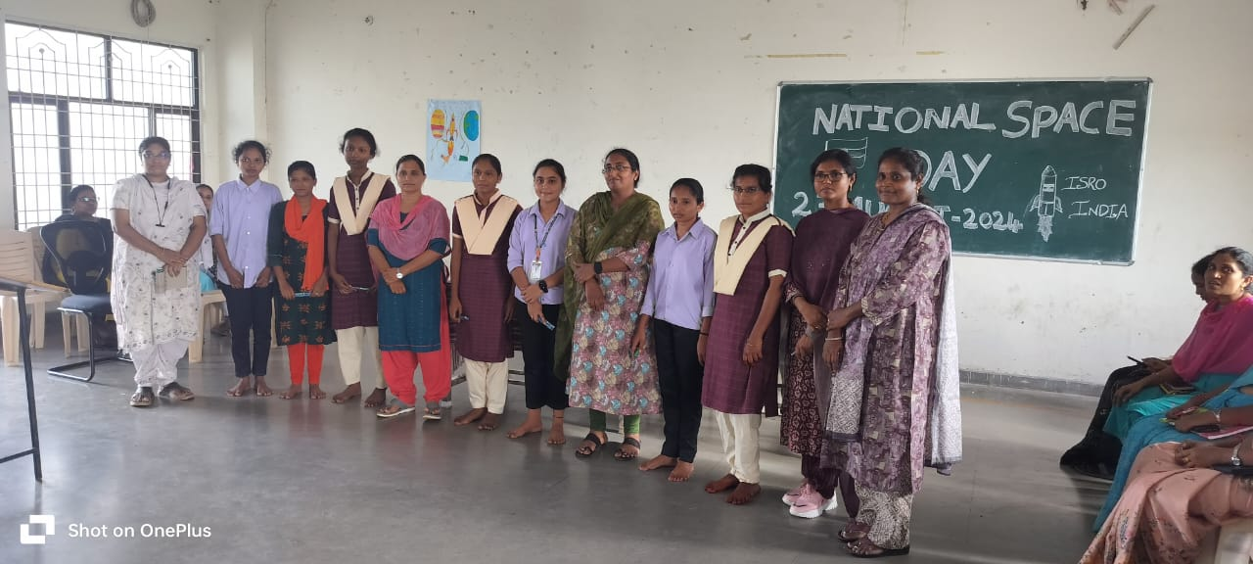



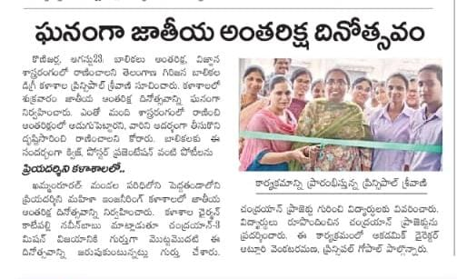

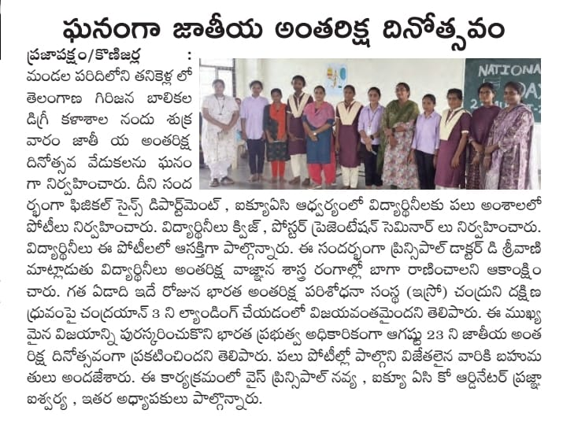

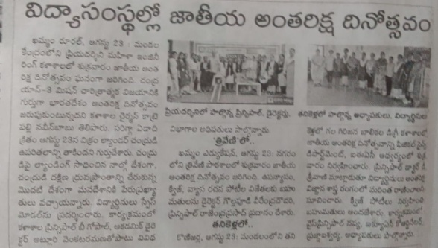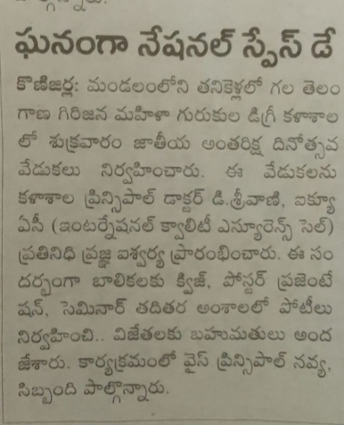

CONCLUSION: NATIONAL SPACE DAY CELEBRATIONS HAVE BEEN A GREAT SUCCESS AND STUDENTS HAVE SHOWN INTEREST IN SPACE EXPLORATION IRRESPECTIVE OF THEIR STREAM.REPRESENTING INDIA ON BEHALF OF TGTWRDC FOR GIRLS KHAMMAM.

JAI HIND!!!

SIGN OF THE FACULTY SIGN OF THE PRINCIPAL